# 

# **Department of Computer Science and Engineering Islamic University of Technology (IUT)** A subsidiary organ of OIC

# **Laboratory Report**

# CSE 4512: Computer Networks Lab

## 

## **Name :** Amina **Student ID :** 200041155 **Section :** 1B (shifted from 1A) **Semester :** 5th (WINTER) **Academic Year :** 2022-23

**Date of Submission :** 25-09-2023

### **Title:** Configuring and Verifying of RIP and OSPF in a network topology.

### **Objective**:

1. Describe the concept of dynamic routing
2. Explain disadvantages of RIPv1 and improvement in RIPv2
3. Configure Routing Information Protocol (RIP) in a network topology following given specifications
4. Describe the concept of OSPF and related terminologies
5. Explain the advantages of OSPF over RIP
6. Configure OSPF in a network topology following the given specifications

### **Devices/ software Used**:

* + - 1. Laptop
      2. Cisco Packet Tracer

### **Theory:**

* **Routing Information Protocol (RIP):** RIP is a distance-vector routing protocol used in computer networks. It is one of the oldest routing protocols still in use. RIP routers exchange routing information with neighboring routers to determine the best path to reach network destinations. RIP uses a metric called "hop count" to measure the distance to a destination network. It is a simple and easy-to-configure protocol but has limitations in larger or complex networks.
* **Forwarding Table used in RIP:** In RIP, routers maintain a forwarding table that contains information about reachable network destinations and the next-hop routers to reach those destinations. This table is used to make forwarding decisions, determining where to send packets based on their destination IP addresses. The forwarding table is populated with information learned from RIP updates received from neighboring routers.
* **Hop Count as cost:** In RIP, the metric used to determine the best path to a network destination is the hop count. Hop count represents the number of routers or "hops" a packet must traverse to reach a particular network. A lower hop count is considered a better metric, meaning that RIP will choose paths with fewer hops as the preferred routes. However, this metric can be a limitation in networks with varying link speeds or other factors that affect the quality of the path.
* **Timers in RIP:** RIP uses timers to control various aspects of its operation. The key timers in RIP include:
  + **Update Timer:** This timer controls how often a router sends its complete routing table to its neighboring routers. By default, RIP sends updates every 30 seconds. If there are changes in the network, an update is sent sooner.
  + **Invalid Timer:** This timer specifies the amount of time a router will wait without receiving updates about a route before considering it invalid. By default, this timer is set to 180 seconds.
  + **Hold-down Timer:** When a router receives an update stating that a route is invalid, it starts a hold-down timer. During this time, the router will not accept any updates for that route, even if they claim a better path. This prevents rapid, unstable route changes.
  + **Flush Timer:** After a route is invalidated and the hold-down timer expires, the route is removed from the routing table after an additional period called the flush timer. By default, this timer is set to 240 seconds.

Timers are essential for maintaining routing stability and preventing routing loops in the RIP protocol. They control how quickly routers react to changes in the network and how long they remember routing information.

### **Diagram of the experiment:**

**Task #01:**

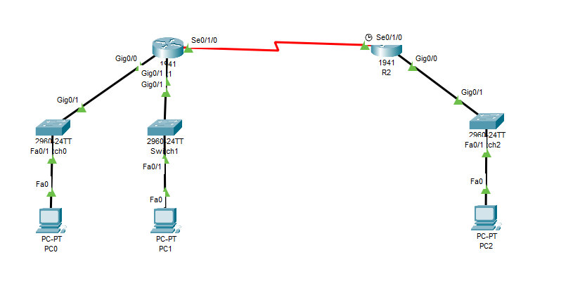

**Task #02:**

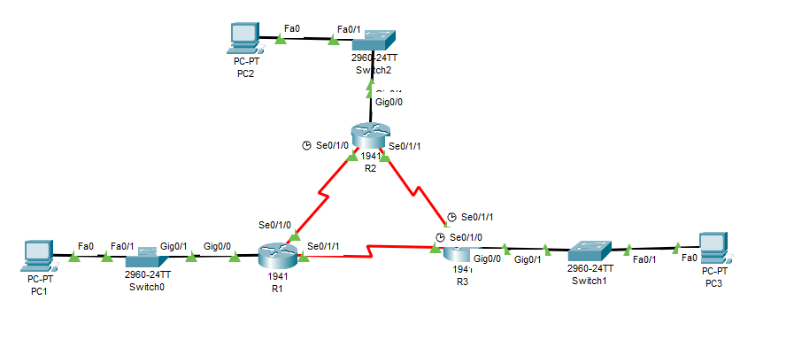

**Task #03:**

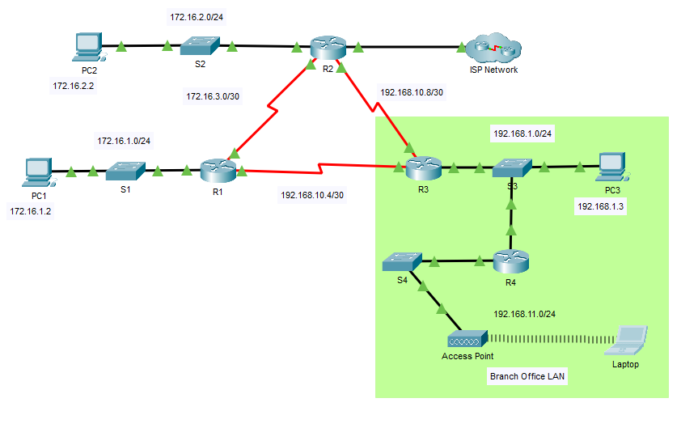

### **Working Procedure:**

**Task #01:**

* **Configuring R1 Router Interfaces:**

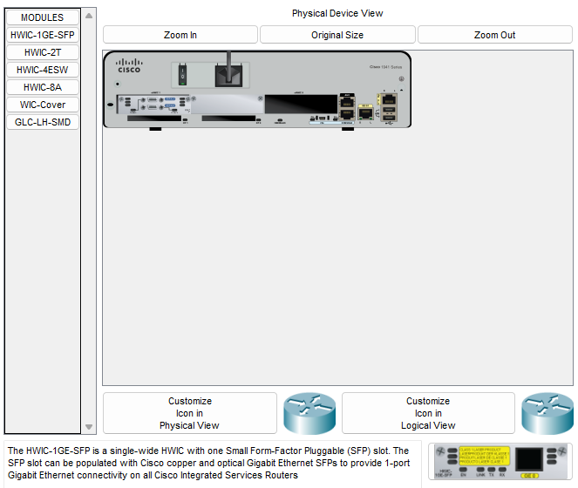

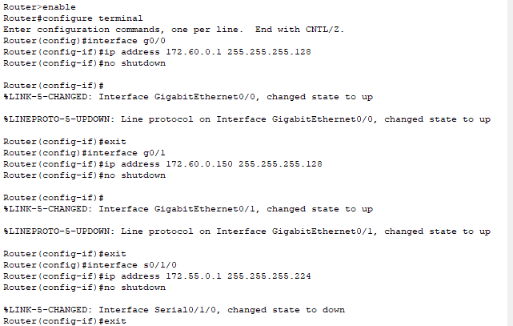



* **Configuring R2 Router Interfaces:**



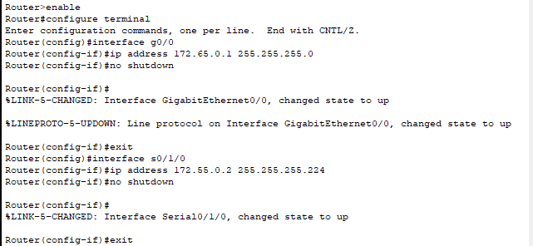



* **Configuring PC0:**

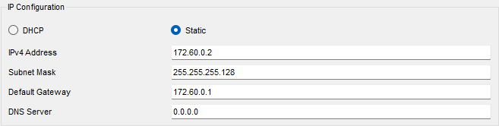

* **Configuring PC1:**

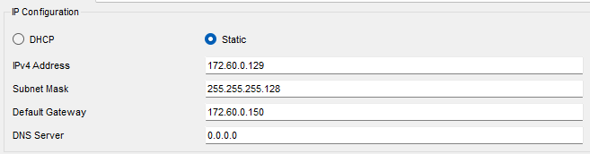

* **Configuring PC2:**

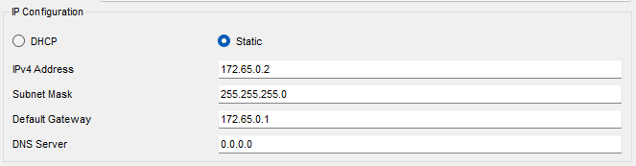

* **Configuring RIP in R1 Router:**

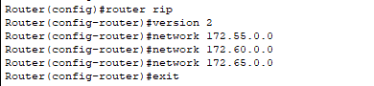

* **Configuring RIP in R2 Router:**

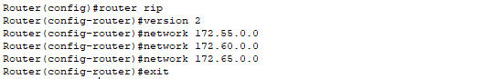

**Task #02:**

* **Configuring R1 Router Interfaces:**



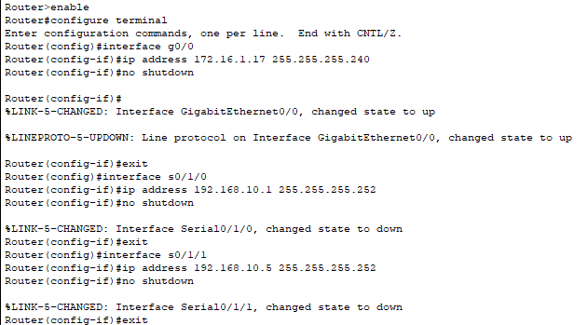

* **Configuring R2 Router Interfaces:**



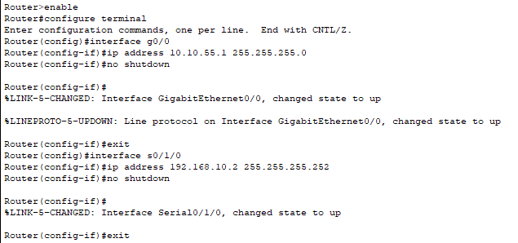

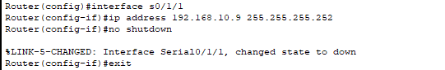

* **Configuring R3 Router Interfaces:**



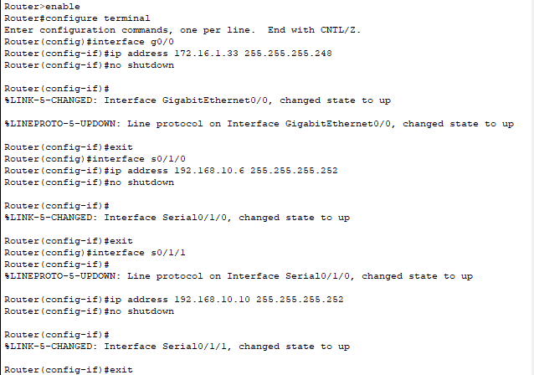

* **Configuring PC1:**

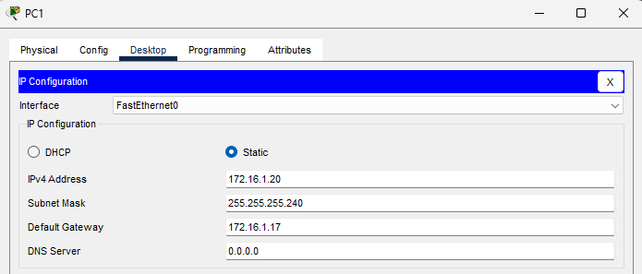

* **Configuring PC2:**

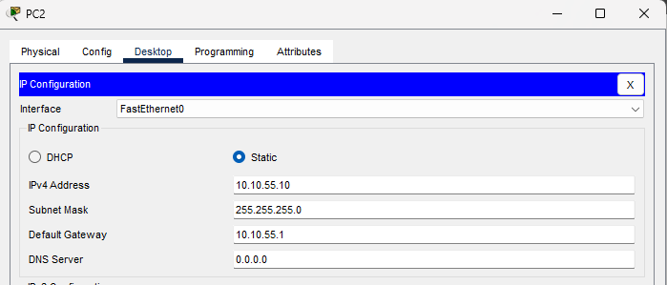

* **Configuring PC3:**

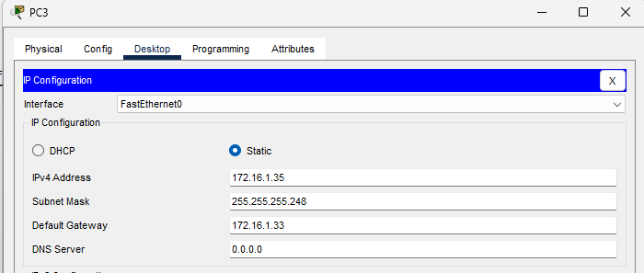

* **Configuring OSPF in R1 Router:**

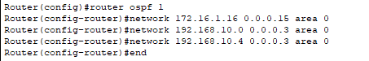

* **Configuring OSPF in R2 Router:**

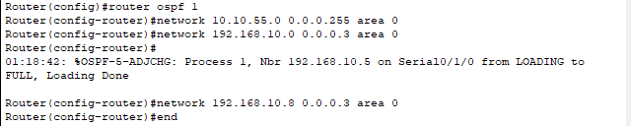

* **Configuring OSPF in R3 Router:**

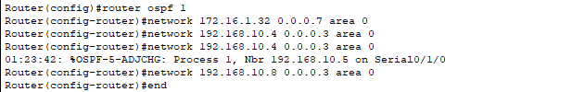

* **Configuring OSPF router-id in R1 Router:**

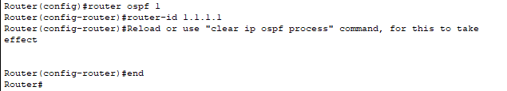

* **Configuring OSPF router-id in R2 Router:**

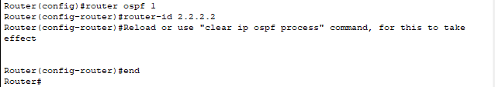

* **Configuring OSPF router-id in R3 Router:**

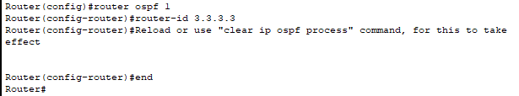

**Task #03:**

* **Logging Into R1 Router:**

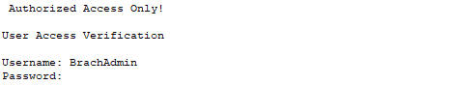

* **Executing ‘*show ip route’* command on R1 Router:**

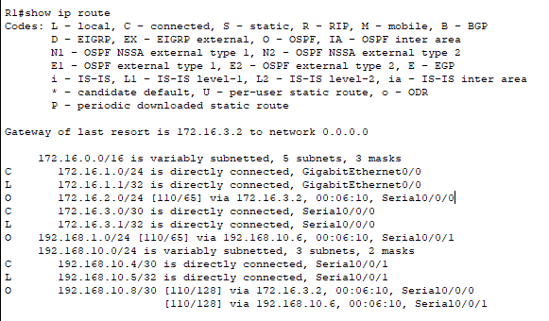

* **Executing ‘*show ip ospf neighbor’* command on R1 Router:**

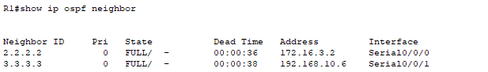

* **Using the command prompt on PC1 pinging the address of the ISP Router:**

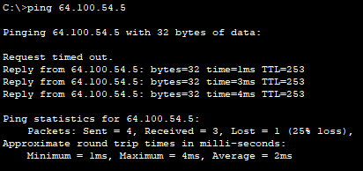

* **Applying *‘clear ip ospf process’* on all routers (R1, R2, R3):**







* **Repeating the previous ping command on PC1:**

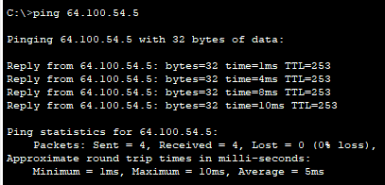

* **Logging Into R2 Router:**



* **Executing ‘*show ip route’* command on R2 Router:**

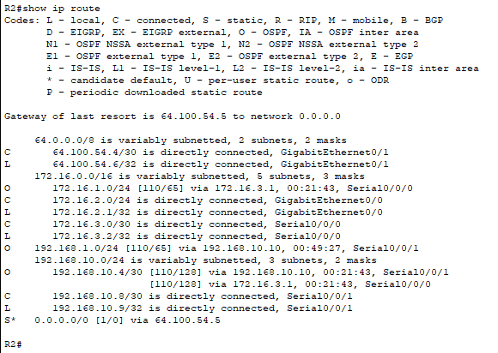

* **Executing ‘*show ip ospf interface g0/0’* command on R1 Router:**

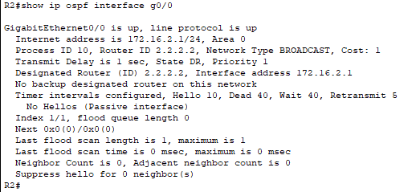

* **Using the command prompt on PC2 pinging the S0/0/1 address on router R3:**

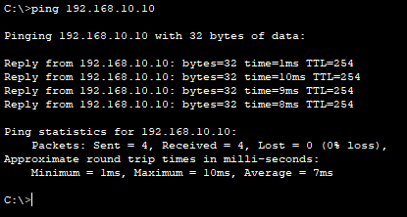

* **Executing ‘*show ip protocols’* command on R3 Router:**

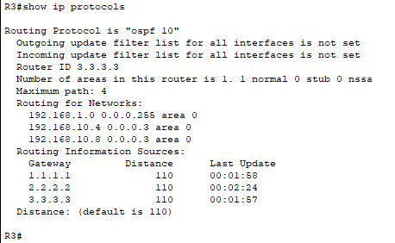

* **Executing ‘*show ip ospf neighbor detail’* command on R3 Router:**

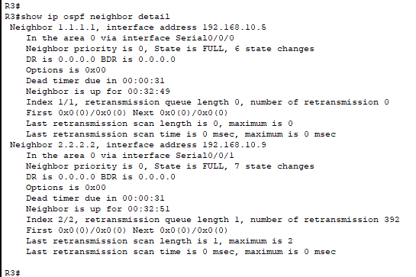

* **Using the command prompt on PC3 pinging the address of the ISP Router:**

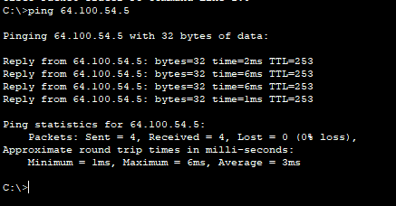

* **Executing ‘*show run | begin router ospf’* command on R4 Router:**

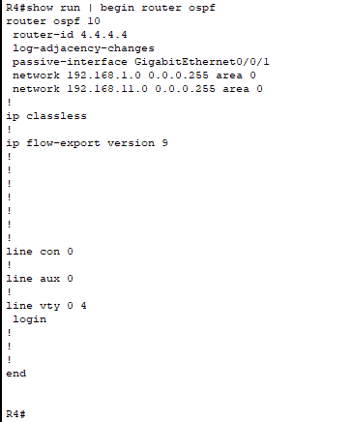

* **Executing ‘*show ip ospf neighbor’* command on R4 Router:**

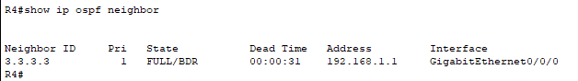

* **Executing ‘*show ip ospf neighbor’* command on R3 Router:**

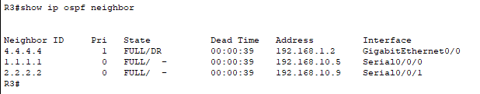

* **Using the command prompt on Laptop pinging the address of PC2:**

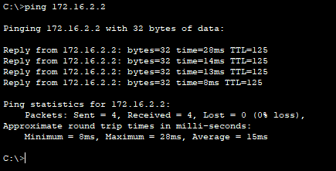

### **Q/A for the tasks:**

**Task #02:**

* **What is the router ID for R1?**

**Ans:** ID1.1.1.1 is given to router R1

* **What is the router ID for R2?**

**Ans:** ID2.2.2.2 is given to router R2

* **What is the router ID for R3?**

**Ans:** ID3.3.3.3 is given to router R3

**Task #03:**

* **How did router R1 receive the default route?**

**Ans:** Through OSPF Version 2 Protocol.

* **From which router did R1 receive the default route?**

**Ans:** From router R2.

* **How can you filter the output of ‘*show ip route’* to show only the routes learned through OSPF?**

**Ans:** By using the command *‘show ip route ospf’.*

* **Which routers have formed adjacencies with router R1?**

**Ans:** router R2 and router R3.

* **What are the router IDs and state of the routers shown in the command output?**

**Ans:**



* **Are all of the adjacent routers shown in the output?**

**Ans:** Yes.

* **Using the command prompt on PC1, ping the address of the ISP Router shown in the Address Table. Is it successful?**

**Ans:** No. Last packet was lost.

* **How did router R2 learn the default route to the ISP?**

**Ans:** Through static routing.

* **What type of OSPF network is attached to this interface?**

**Ans:** Broadcast.

* **Are OSPF hello packets being sent out this interface? Explain.**

**Ans:** No. Because the interface is a passive interface which means that OSPF routing updates, including hello packets, are not sent or received on that interface.

* **Using the command prompt on PC2, ping the S0/0/1 address on router R3. Is it successful?**

**Ans:** Yes.

* **Router R3 is routing for which networks?**

**Ans:**



* **What is the neighbor priority shown for the OSPF neighbor routers? This value is the default.**

**Ans:** The priority value is 0.

* **Using the command prompt on PC3, ping the address of the ISP Router shown in the Address Table.** **Is it successful?**

**Ans:** Yes.

* **Which interface is configured to not send OSPF update packets?**

**Ans:** GigabitEthernet 0/0/1.

* **What state is displayed for router R3?**

**Ans:** FULL/BDR.

* **Why is the state of router R4 different than the state of R1 and R2?**

**Ans:** Because R4 is having the role of Backup Designated Router (BDR) in multi-access network 192.168.1.0/24 which is ready to assume the role of the Designated Router (DR) if needed and they maintain adjacency with the current DR (R3) and ensure a smooth transition if the DR fails. On the other hand, R1 and R2 are fully adjacent OSPF neighbors with the ability to actively participate in OSPF routing.

* **Using the command prompt on Laptop, ping the address of PC2. Is it successful?**

**Ans:** Yes.

### **Observation**:

**Task #01:**

* **Verifying R1 Router for RIP:**



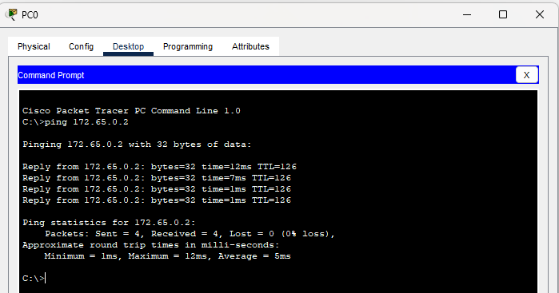

* **Verifying R2 Router for RIP:**



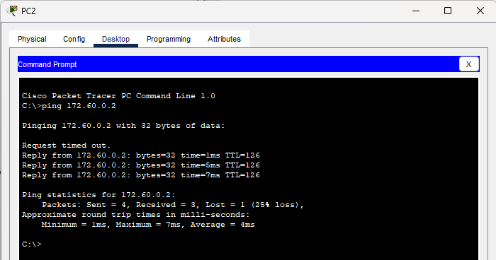

**Task #02:**

* **Verifying R1 Router for OSPF:**

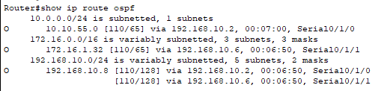

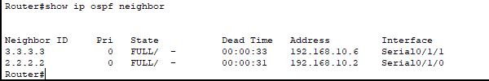

* **Verifying R2 Router for OSPF:**

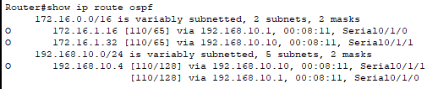

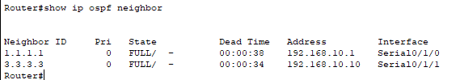

* **Verifying R3 Router for OSPF:**

